

Semester One Examination, 2012

Question/Answer Booklet

Please place your student identification label in this box
3AB PHYSICS

Student Number: In figures

In words

Time allowed for this paper
Reading time before commencing work: Ten minutes
Working time for paper: Three hours

Materials required/recommended for this paper

To be provided by the supervisor
This Question/Answer Booklet
Formulae and Constants Sheet

To be provided by the candidate
Standard items: pens, pencils, eraser, correction fluid, ruler, highlighters
Special items: non-programmable calculators satisfying the conditions set by the Curriculum Council for this course

Important note to candidates
No other items may be taken into the examination room. It is your responsibility to ensure that you do not have any unauthorised notes or other items of a non-personal nature in the examination room. If you have any unauthorised material with you, hand it to the supervisor before reading any further.
 | Section 1 | Section 2 | Section 3 | Total
Score
Out of | 45 | 75 | 30 | 150
%
Structure of this paper

Section | Number of questions available | Number of questions to be answered | Suggested working time  (minutes) | Marks available | Percentage of exam
Section One:  Short response | 12 | 12 | 54 | 45 | 30
Section Two:  Problem-solving | 7 | 7 | 90 | 75 | 50
Section Three:  Comprehension | 2 | 2 | 36 | 30 | 20
 |  |  |  |  | 100

Instructions to candidates

1. All numerical answers must be stated to 3 significant figures. Questions containing estimates should be stated to two significant figures.

2. The rules for the conduct of Curriculum Council examinations are detailed in the Student Information Handbook. Sitting this examination implies that you agree to abide by these rules.

3. Write answers in this Question/Answer Booklet.

4. You must be careful to confine your responses to the specific questions asked and to follow any instructions that are specific to a particular question.

5. Working or reasoning should be clearly shown when calculating or estimating answers.

6. Spare pages are included at the end of this booklet. They can be used for planning your responses and/or as additional space if required to continue an answer.

Planning:
If you use the spare pages for planning, indicate this clearly at the top of the page.

Continuing an answer:
If you need to use the space to continue an answer, indicate in the original answer space where the answer is continued, i.e. give the page number. Fill in the number of the question(s) that you are continuing to answer at the top of the page.

Section One: Short response - 30% (45 Marks)

This section has 12 questions. Answer all questions. Write your answers in the space provided.

Spare pages are included at the end of this booklet. They can be used for planning your responses and/or as additional space if required to continue an answer.
Planning: If you use the spare pages for planning, indicate this clearly at the top of the page.
Continuing an answer: If you need to use the space to continue an answer, indicate in the original answer space where the answer is continued, i.e. give the page number. Fill in the number of the question(s) that you are continuing to answer at the top of the page.

Suggested working time for this section is 54 minutes.

Question 1 (3 marks)

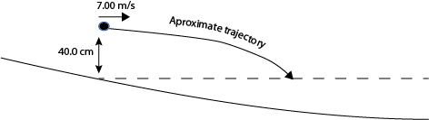

Some children are down at a lake skimming pebbles on the flat water. One child stands at the edge of the water and throws a pebble (rock) with a purely horizontal velocity of 7.00 m/s. If the rock is thrown from a distance of 40 cm above the water, how far from the thrower does the rock first strike the surface of the water? Assume no air resistance.

Question 2 (5 marks)

A 50.0 kg gymnast is swinging around a bar in a vertical circle. Assume no additional energy is suppled or removed from the situation.

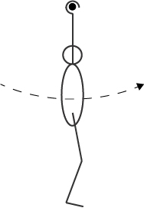

The gymnast’s centre of mass (hips) is positioned 0.95 m from the bar. If the gymnast has a velocity of 7.41 m/s as she passes the lowest point in her circle, what will be the size and direction of the force exerted on the gymnast’s centre of mass by her arms as she passes the highest point in her circle?

Question 3 (4 marks)

A father takes his children to the Perth Zoo. At the zoo they go on the merry go round which has a period of rotation of 20.0 s. There are 2 rows of horses. The outer row of horses is positioned 5.50 m from the centre and the inner row is 4.8 m from the centre.

Top View Diagram
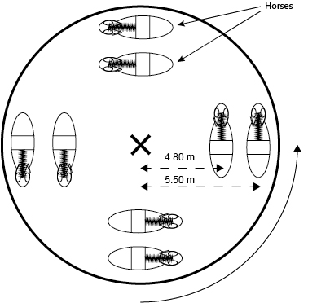

Hannah (of mass 25 kg) sits on the inner horse and Leo (of mass 20 kg) sits on an outer horse. Calculate which child experiences the greater centripetal force?

Question 4 (3 marks)

As an object with mass moves away from a planet its weight decreases. Below is a graph of the relationship between the weight of a 70 kg object and its distance from the centre of the planet earth.

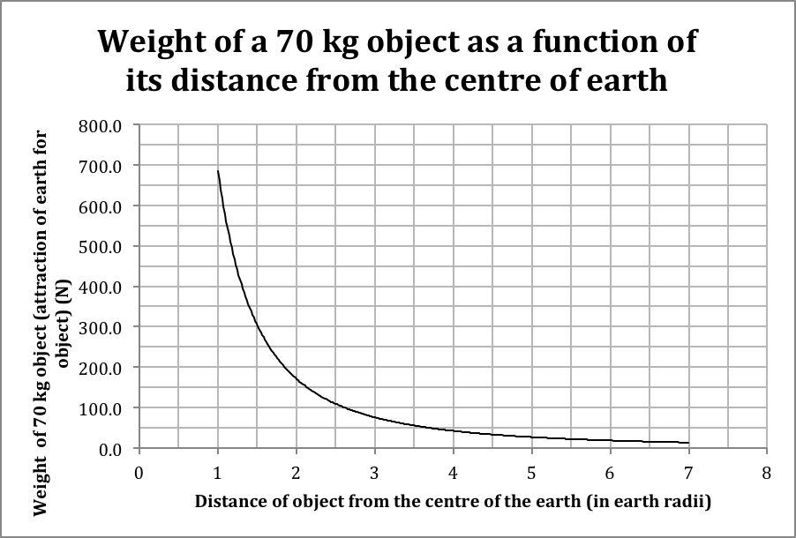

- What physical quantity does the area under the curve represent?
(1 mark)
____________________________

b) Determine the area under the curve in S.I. units between the 2 earth radii and 4 earth radii points. Be sure to use the appropriate units and leave evidence of your method on the graph.
(2 marks)

Question 5 (3 marks)

The asteroid belt lies between Mars and Jupiter. Some asteroids are closer to the sun than others. Many of the asteroids are in a stable circular orbit around the sun. What is the ratio of the period of revolution of Asteroid A positioned 2.4 AU from the sun compared to Asteroid B positioned 3.1 AU from the Sun?

Note 1 AU is the distance from the sun to the Earth.

Question 6 (4 marks)

A bucket with its bottom removed is shown in two positions below

Upside Down Right Way Up



a) Of the two positions shown below, circle which position is the most stable? Explain why.
(2 marks)

b) Draw this bucket in an unstable and a neutral equilibrium on the ground line provided below.
(2 marks)

unstable equilibrium neutral equilibrium

Question 7 (4 marks)

Here is a diagram of a bicycle wheel. Assume the bike is attached to the axle of the wheel.

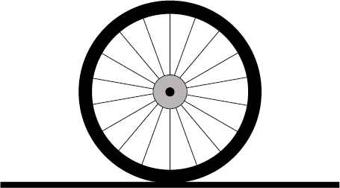

a) Put a tick on the spoke that is under the greatest tension.
(1 mark)

b) Put a cross on the spoke that is under the least tension or is under the greatest compression.
(1 mark)

c) If you had the bike wheel in front of you and you were allowed to test your answer to a) and b) above in any way you chose, how could you test your answers?
(2 marks)

Question 8 (4 marks)

A system of 1.00 m rulers pivoted at their centres and attached to each other by strings is set up as shown below and a Push is applied on the top ruler to keep the system in equilibrium. The widely spaced scale divisions on the rulers represent distances of
10.0 cm each and all attachment points are accurate to the nearest 10.0 cm.

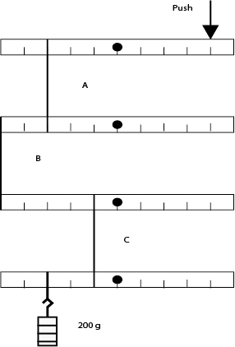

a) If each uniform ruler has a mass of 50.0 g, will the mass of the ruler need to be considered in your calculation of the Push? Explain.
(2 marks)

b) Calculate the size and direction of the Push provided to keep the system of 1.00 m rulers in balance?
(2 marks)

Question 9 (4 marks)

A particular humming bird being studied by a biology student is flapping its wings up and down with a frequency of 6000 flaps (cycles) per minute.

a) What is the frequency per second?
(1 mark)

b) What is the period of the wing movement?
(1 mark)

c) Graph the wing tip movement if a wing tip travels a distance of 10.0 cm in one complete cycle.
(2 marks)
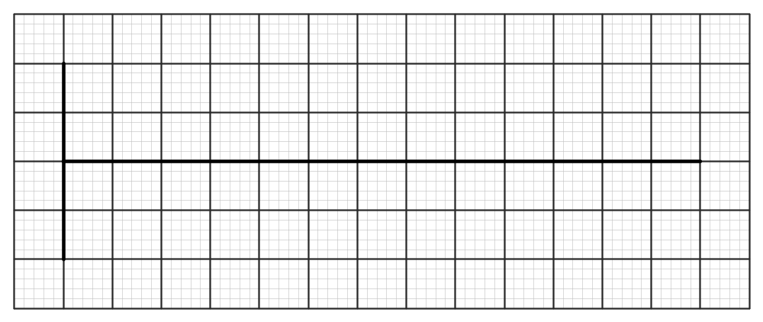

Question 10 (4 marks)

A 2.40 m long snake is wiggling across a flat sandy desert floor. A brave physicist notices that the snake’s body shape consists of 3.5 cycles. If the snake is travelling at 4.32 km/h what is the period of the snake’s movement?

Question 11 (4 marks)

The below diagram represents a sound wave approaching a concrete wall from air. Some of the sound enters the wall and some bounces off it. Sketch the pathways taken and the wavelengths of the entering and bouncing waves onto the diagram below. No calculations are required.

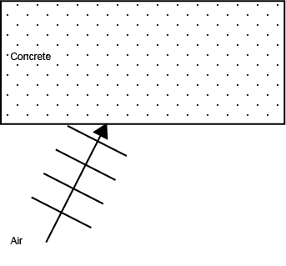

Question 12 (3 marks)

A student is trying to calculate the error in the centripetal force acting on a tennis ball swinging in a horizontal circle around a pole on a string

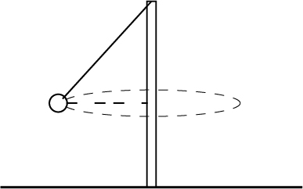

The data for the calculation is as follows …

Quantity | Amount | Absolute Error | Relative Error
Tennis ball mass | 57.6 g | ± 0.9 g
Speed of ball | 5.0 m/s | ± 0.05 m/s
Radius of circle (horizontal) | 1.1 m | ± 0.05 m

a) Calculate the relative error for each quantity and so complete the data table above.
(1 mark)

b) What is the relative error in the centripetal force? Show working.
(1 mark)

c) What is the absolute error in the centripetal force? Show working.
(1 mark)

End of Section One
Section Two : Problem-Solving - 50% (75 Marks)

This section has seven (7) questions. You must answer all questions. Write your answers in the space provided.

Spare pages are included at the end of this booklet. They can be used for planning your responses and/or as additional space if required to continue an answer.
Planning: If you use the spare pages for planning, indicate this clearly at the top of the page.
Continuing an answer: If you need to use the space to continue an answer, indicate in the original answer space where the answer is continued, i.e. give the page number. Fill in the number of the question(s) that you are continuing to answer at the top of the page.

Suggested working time for this section is 90 minutes.

Question 13 (11 marks)

A 2.00 L plastic coca cola bottle is partially filled with water and compressed air. When the seal on the bottle is broken the water and air forces its way out of the bottle launching the bottle in to the air. Ignore air resistance in your calculations.

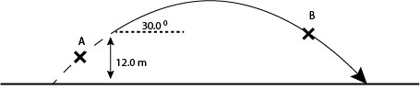

The mass of the bottle changes during the flight as the water blasts out of the bottle. All of the water has left the bottle by the time that the bottle has reached the 12 m high mark.

a) Draw and label the forces acting on the bottle at points A and B on the flight path above.
(2 marks)

b) At the moment that the bottle becomes a projectile it has a height of 12.0 m, a trajectory 30.0 ⁰ above the horizontal and a velocity of 8.50 m/s along its flight path. What is the maximum height above the ground that it will reach?
(3 marks)

c) What is the range of the projectile measured from the moment it becomes a projectile?
(3 marks)

d) At what angle does the bottle hit the ground relative to the horizontal?
(3 marks)

Question 14 (10 marks)

One of the games played at a Casino is roulette. In this game a large horizontal wheel containing black and red squares is spun anticlockwise. At the same time a small white 3.74 g ball is sent clockwise around an 80 cm diameter small track or groove built into the outside of the wheel. The ball falls in to one of the squares of the wheel when the speed of the ball is too slow to keep the ball on its track. Assume no rolling friction.

Top View

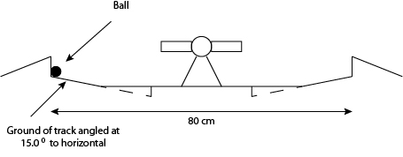
Side View

a) What is the centripetal force on the ball if it competes one revolution of the circle each second?
(3 marks)

b) Draw the forces acting on the ball as it rolls around the edge.
(3 marks)

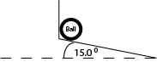

c) As the ball rolls slower all of the centripetal force is provided by the 15.0 ⁰ slope only. At what speed will the ball be travelling in its 80.0 cm diameter circle when this occurs.
(4 marks)

Question 15 (11 marks)

A binary star system consists of two stars that are orbiting around each other. Each of the two stars orbits around a point called the centre of mass that exists on the line joining the centres of the two stars. The combined mass of the two stars appears to act at the centre of mass (C) generating a centripetal force that acts on each star (m and M) separately. Each star experiences the same centripetal force.

Alpha Beta
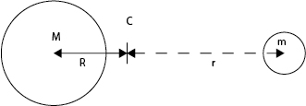

Star Name | Distance of star from centre of mass (C) | Period of revolution | Speed of star | Mass of star
Alpha | 7.50 x 10¹⁰ m | 2.13 years |  | M
Beta | 3.75 x 10¹¹ m | 2.13 years |  | m

a) What is the period of revolution of both the stars in seconds?
(1 mark)

b) What is the speed of revolution of Beta?
(2 marks)

c) What is the centripetal acceleration of Alpha?
(3 marks)

d) The centripetal force on each of the two stars is the same. Calculate the ratio of the mass of Alpha to the mass of Beta. (Alpha : Beta)
(3 marks)

e) If Beta has a mass equal to that of our sun, what is the mass of alpha? If you were unable to find a ratio in part d) use the ratio of 6 : 1 in your answer below.
(2 marks)

Question 16 (10 marks)

A bike rides over a bridge made from a plank (piece of wood) stretched between two triangular boxes. The distance between the two boxes is 3.20 m and the distance between the two wheels is 0.900 m. The combined mass of the bike and rider is 80.0 kg. Assume the rider is on the bike in all questions below. The weight of the bike and rider is 60.0 % on the back wheel and 40.0 % on the front wheel. The plank has a mass of 20.0 kg.

a) Draw and label the forces acting on the plank when the bike (and rider) is in the middle of the plank as shown in the diagram below. Note that the wheels make separate points of contact on the plank.
(3 marks)

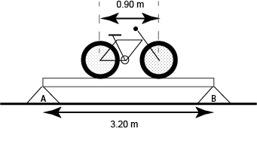

b) Calculate the force on the left and right boxes when the bike is in the middle as shown in the diagram above.
(3 marks)

c) If you could move the bike to any position on the plank to maximise the force on A and still have both wheels in contact with the plank, where would the bike be situated? Draw this on the diagram below.
(1 mark)

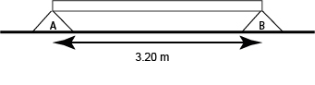
d) Calculate the force on B in the diagram above.
(3 marks)

Question 17 (14 marks)

A sailor is calculating the forces acting on the boom of his sailing boat when it is at rest in harbour. The Boom is 1.8 m long and is connected to the top of the Mast by a rope not a sail. The Boom is uniform and has a mass of 30.0 kg.

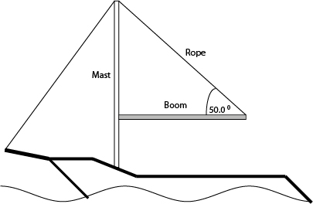

a) Draw all of the forces acting on the boom.
(3 marks)

b) What is the tension in the Rope that joins the end of the Boom to the top of the Mast?
(3 marks)

c) What is the magnitude and direction of the force acting on the Boom at the point of contact between the Boom and the Mast?
(4 marks)

d) A massless pulley is now attached to the Boom 1.50 m from the mast. When the sailor pulls on the Pulley Rope the tension in the Original Rope connecting the mast to the boom increases to 600.0 N. What is the force applied by the sailor to the rope passing through the pulley?
(4 marks)
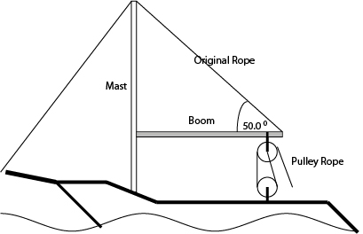

Question 18 (7 marks)

a) Draw a picture in the box (not a graph) of air which has no sound passing through it.
(1 mark)

b) Draw a picture in the box (not a graph) of air that has a loud sound of frequency 6920 Hz passing through it from left to right. Be sure to show 2 complete wavelengths.
(2 marks)

c) Is this sound in part b) audible to the human ear? Explain with reference to the range of human hearing.
(2 marks)

d) How would the picture look different if the sound had a higher frequency and smaller amplitude when compared with part b) above?
(2 marks)

This page is intentionally blank

Question 19 (12 marks)

A set of slotted masses is hanging from a pulley at the bottom of a piece of string that is run through the pulley as shown.

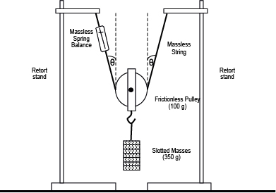

The student gradually increases the distance between the two retort stands by dragging them away from each other. This alters the angle between the pulley string and the vertical. The student then records the force measured on the spring balance.

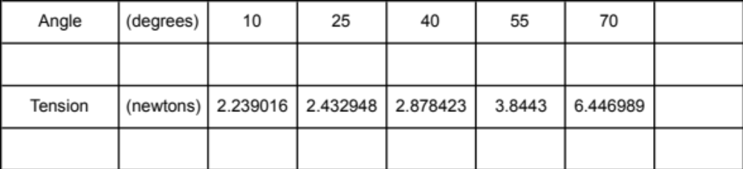

It is thought that the relationship between the angle created in the string and the tension in the string is given by
T = ½ mg / Cos θ

a) What is the independent variable?
(1 mark)

b) What is the dependent variable?
(1 mark)

c) Manipulate either the independent or the dependent variable in the data table above in preparation for creating a straight-line graph.
(2 marks)

d) Graph the manipulated data to produce a straight line
(4 marks)
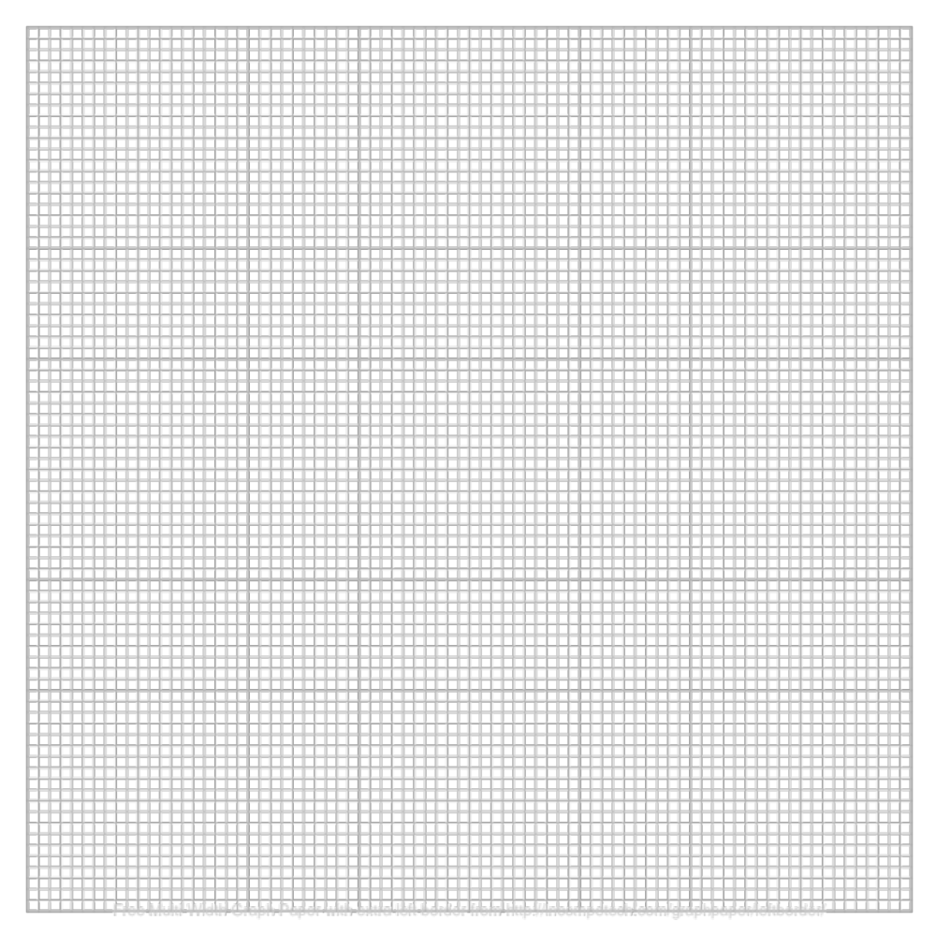
e) Use the graph to calculate the slope of the line
(3 marks)

f) Use the slope of the line to calculate the mass in the equation.
(1 mark)

Section Three: Comprehension - 20% (30 Marks)

This section contains two (2) questions. You must answer both questions. Write your answers in the space provided.

Spare pages are included at the end of this booklet. They can be used for planning your responses and/or as additional space if required to continue an answer.
Planning: If you use the spare pages for planning, indicate this clearly at the top of the page.
Continuing an answer: If you need to use the space to continue an answer, indicate in the original answer space where the answer is continued, i.e. give the page number. Fill in the number of the question(s) that you are continuing to answer at the top of the page.

Suggested working time for this section is 36 minutes.

Question 20 (15 marks)

The Physics of Bicycles

What goes in circles but still helps you get to your destination faster… a bicycle!
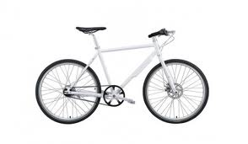

Figure 1 – A Bicycle with gears

Paragraph 1
Bicycles have been around for hundreds of years and the most successful models have gears. The gears and drive chain on a bike allow the bike to convert between linear-force and rotational-torque and visa versa. This interplay between force and torque allows the bicycle to achieve its purpose as a machine.

Paragraph 2
Firstly we need to discuss cogs. A bike with gears usually has two sets of cogs. One set of cogs is attached to the pedals and cranks. The other set of cogs is attached to the rear wheel. All of the teeth on these cogs are set the same distance apart because the chain links in the chain that mesh with the cogs are all the same size. The chain link size and hence the teeth spacing on a typical bicycle is 9.00 mm. Consequently the circumference of a cog is always a multiple of this 9.00 mm link size.

A diagram of the rear part of a bicycle (relevant parts) is shown below …

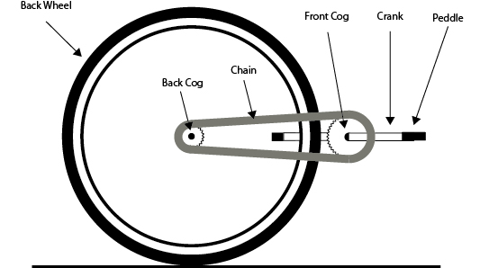

Figure 2 – the rear section of a simple bicycle.

Paragraph 3
A flow chart of the force / torque interplay from the pedal to back wheel …

1. Force applied to pedal (weight of person).

2. Force converted to torque by crank.

3. Torque of crank is transferred to the front cog.

4. Torque of front cog is converted to force in chain.

5. Force in chain is passed to the back cog.

6. Force of chain on cog converted to torque.

7. Torque of cog equals the torque given to back wheel.

8. Torque of wheel applies force to the ground.

This is how the force is transferred from the pedals to the ground at right angles.

References

http://en.wikipedia.org/wiki/Bicycle_gearing
Questions.

a) A person is riding a simple bicycle that is using a 40 tooth front cog and a 23 tooth back cog. What is the radius of each of these cogs given that each chain link and hence teeth spacing is 9.00 mm?
(4 marks)

b) What is the torque applied to the front cog if the crank is 170 mm long and the complete weight of a 60.0 kg person is applied to the pedal when the crank is at 30.0⁰ to the horizontal?
(3 marks)

c) Calculate the magnitude of the force applied to the chain by the front cog.
(1 mark)

d) What torque is applied to the back cog by the chain?
(1 mark)

e) What force does the wheel apply to the ground (at a tangent to the wheel) if the wheel has a diameter of 680 mm?
(1 mark)

f) What is the ratio of the weight force applied to the pedal as compared to the force applied by the wheel to the ground?
(1 mark)

g) What is the instantaneous acceleration of the bicycle if it has a mass 30.0 kg and the rider has a mass of 60.0 kg?
(2 marks)

h) Does the bicycle cog system provide the rider with a force advantage or a distance advantage? Explain.
(2 marks)

Question 21 (15 marks)

Good Fenced Make Good Neighbours
(Farm Fencing and Gates)

Note – Diagrams in this article depict wires as a dashed lines and posts as rectangles.
Fences
Paragraph 1
Fencing is an important part of any farm it is often one of the least loved jobs because of the monotony of the repair task and the need to check regularly for damage from animals. If the job can be done correctly when the fence is first installed then money and time can be save in the longer term.

Paragraph 2
Fences are made generally from metal or wooden poles put in the ground vertically with horizontal fencing wire running (nearly without friction) through the fence poles. The horizontal wire is kept tight by attaching it securely to the end poles of the fence line. The wire tension pulls on the end poles only causing them to bend inwards towards the centre of the fence.

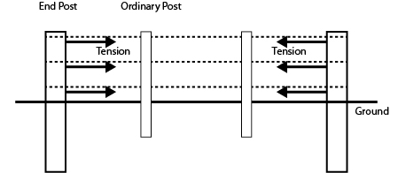

Figure 1 - End posts tend to rotate inwards towards the centre of the fence.

Paragraph 3
Many farm fences are 1.4 m high above ground level. The rule used to calculate the depth to which a standard fence post should be buried is “2/3rds of the post length should be above the ground and 1/3rd of the post length should be buried”. This will allow the soil around the post to provide sufficient support to withstand the slight toppling forces of the wires and any bumps from livestock (assuming that the post pivots at ground level). End posts should be buried to the “½ above ½” below rule due to the large forces that the wire places on them. The end posts should also be of a larger diameter.

Paragraph 4
Unfortunately in the longer term the end posts of a fence will rotate inwards. This is because the soil in which the fence post is placed is not totally solid. Soil can instead be thought of as being more like a very thick (viscous) honey. A spoon placed into a cup of honey will stand for a while but will eventually fall over. So it is with the end posts on a fence.

Paragraph5
To reduce this effect the end post of a fence can be braced (reinforced) either using metal/wooden posts or using fencing wire on the diagonal. Two methods are shown below.

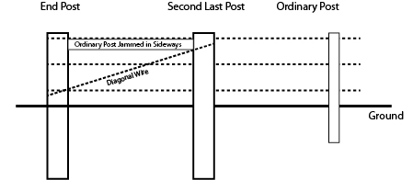

Figure 2a - Post and Wire bracing method. An ordinary post is jammed between the last and second last posts and diagonal wire is applied tightly from the top of the second last post to the bottom of the last.

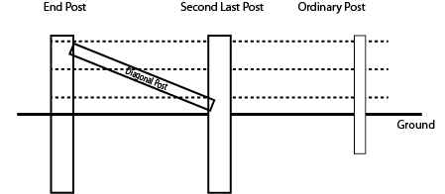

Figure 2b – Post only bracing method. A diagonal post is applied between the top of the last post and the bottom of the second last post.

Paragraph 6
Fences should not be more than 60 m long if single bracing is to be used and 200 m long if double braced. This is because the changing temperature of the wire as the weather changes will change the amount of force exerted on the end posts, potentially pulling over the end posts.

Gates
Paragraph 7
A fenced field still requires access. This is where gates come into play. Gates are often heavier than the other parts of the fencing system and for this reason gate posts like end posts are thicker and buried deeper (½ above ½ below rule).

Paragraph 8
Gate posts are reinforced differently because the forces of the gate on the post are directed away from the fence rather than towards it.

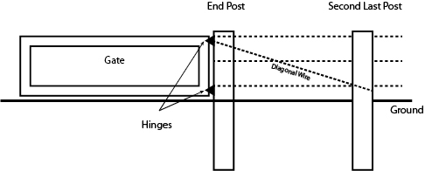

Figure 3 – Gate post braced with wire.

Questions

a) 3 strands of wire are exerting a force of 890 N each on an end post of a fence. If the post pivots at ground level, what is the torque that the ground must supply to stop the post from falling over?
(3 marks)
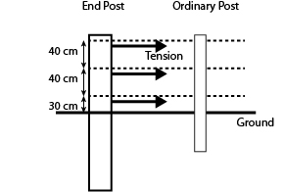

b) If a fence post is to stand 1.20 m above the ground, how deeply must that post be buried if it is …

i) an ordinary post?
(1 mark)

ii) an end post?
(1 mark)

c) Why does the tension in the wire vary as the temperature of the wire changes?
(1 mark)

d) Will the tension in a strand of wire increase or decrease as the temperature drops?
(1 mark)
Increase Decrease (please circle one only)

e) Label each of the pieces of this braced end post set up as being under a tension force, compression force or bending force.
(4 marks)
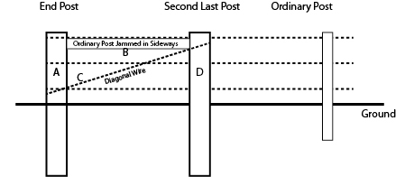

Tension, Compression or Bending
A
B
C
D

f) What is the horizontal force provided by the top hinge on this 100 kg uniform gate? The hinges are symmetrically spaced 90 cm apart. The gate is 1.50 m long and 1.20 m high. Assume the bottom hinge supports the full weight of the gate.
(4 marks)
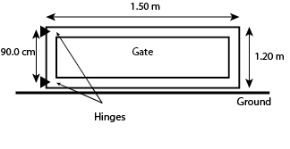

End of Exam

Additional working space

Additional working space

Additional working space

Additional working space

Semester One Examination, 2012

Question/Answer Booklet

Answers

3AB PHYSICS

Student Number: In figures

In words

Time allowed for this paper
Reading time before commencing work: Ten minutes
Working time for paper: Three hours

Materials required/recommended for this paper

To be provided by the supervisor
This Question/Answer Booklet
Formulae and Constants Sheet

To be provided by the candidate
Standard items: pens, pencils, eraser, correction fluid, ruler, highlighters
Special items: non-programmable calculators satisfying the conditions set by the Curriculum Council for this course

Important note to candidates
No other items may be taken into the examination room. It is your responsibility to ensure that you do not have any unauthorised notes or other items of a non-personal nature in the examination room. If you have any unauthorised material with you, hand it to the supervisor before reading any further.
 | Section 1 | Section 2 | Section 3 | Total
Score
Out of | 45 | 75 | 30 | 150
%
Structure of this paper

Section | Number of questions available | Number of questions to be answered | Suggested working time  (minutes) | Marks available | Percentage of exam
Section One:  Short response | 12 | 12 | 54 | 45 | 30
Section Two:  Problem-solving | 7 | 7 | 90 | 75 | 50
Section Three:  Comprehension | 2 | 2 | 36 | 30 | 20
 |  |  |  |  | 100

Instructions to candidates

1. All numerical answers must be stated to 3 significant figures. Questions containing estimates should be stated to two significant figures.

2. The rules for the conduct of Curriculum Council examinations are detailed in the Student Information Handbook. Sitting this examination implies that you agree to abide by these rules.

3. Write answers in this Question/Answer Booklet.

4. You must be careful to confine your responses to the specific questions asked and to follow any instructions that are specific to a particular question.

5. Working or reasoning should be clearly shown when calculating or estimating answers.

6. Spare pages are included at the end of this booklet. They can be used for planning your responses and/or as additional space if required to continue an answer.

Planning:
If you use the spare pages for planning, indicate this clearly at the top of the page.

Continuing an answer:
If you need to use the space to continue an answer, indicate in the original answer space where the answer is continued, i.e. give the page number. Fill in the number of the question(s) that you are continuing to answer at the top of the page.

Section One: Short response - 30% (45 Marks)

This section has 12 questions. Answer all questions. Write your answers in the space provided.

Spare pages are included at the end of this booklet. They can be used for planning your responses and/or as additional space if required to continue an answer.
Planning: If you use the spare pages for planning, indicate this clearly at the top of the page.
Continuing an answer: If you need to use the space to continue an answer, indicate in the original answer space where the answer is continued, i.e. give the page number. Fill in the number of the question(s) that you are continuing to answer at the top of the page.

Suggested working time for this section is 54 minutes.

Question 1 (3 marks)

Some children are down at a lake skimming pebbles on the flat water. One child stands at the edge of the water and throws a pebble (rock) with a purely horizontal velocity of 7.00 m/s. If the rock is thrown from a distance of 40 cm above the water, how far from the thrower does the rock first strike the surface of the water? Assume no air resistance.

Vertical | Horizontal
s = ut + ½ at²  -0.40 = 0 + 0.5 x -9.8 x t²  t = 0.2857 s | v = s / t  7 = s / 0.2857  s = 2.00 m

Question 2 (5 marks)

A 50.0 kg gymnast is swinging around a bar in a vertical circle. Assume no additional energy is suppled or removed from the situation.

The gymnast’s centre of mass (hips) is positioned 0.95 m from the bar. If the gymnast has a velocity of 7.41 m/s as she passes the lowest point in her circle, what will be the size and direction of the force exerted on the gymnast’s centre of mass by her arms as she passes the highest point in her circle?

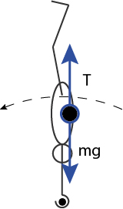

Vertical Forces | Energy
(-mg) + (+N) = (-mv² /r)  (-50 x 9.8) + (N) = (-50 x 4.2² / 0.95)  -490 + N = -928.4  N = -928.4 + 490  N = - 438 N  N = 438 N down | ½ mu² = ½ mv² + mgh  0.5x50x7.41² = 0.5x50xv² + 50x9.8x1.9  1372.7 = 25v² + 931  25v² = 441.7  v² = 17.668  v = 4.20 m s⁻¹

Question 3 (4 marks)

A father takes his children to the Perth Zoo. At the zoo they go on the merry go round which has a period of rotation of 20.0 s. There are 2 rows of horses. The outer row of horses is positioned 5.50 m from the centre and the inner row is 4.8 m from the centre.

Top View Diagram

Hannah (of mass 25 kg) sits on the inner horse and Leo (of mass 20 kg) sits on an outer horse. Calculate which child experiences the greater centripetal force?

Hannah (25 kg) (r = 4.8 m) | Leo (20 kg) (r = 5.5 m)
v = 2 pi r / T  v = 2 x 3.142 x 4.8 / 20  v = 1.50816 m/s  F_{c} = mv² / r  F_{c} = 25 x 1.50816² / 4.8  F_{c} =11.847 N  F_{c} =11.8 N towards the centre | v = 2 pi r / T  v = 2 x 3.142 x 5.5 / 20  v = 1.7281 m/s  F_{c} = mv² / r  F_{c} = 20 x 1.7281² / 5.5  F_{c} = 10.859 N  F_{c} = 10.9 N towards the centre

Question 4 (3 marks)

As an object with mass moves away from a planet its weight decreases. Below is a graph of the relationship between the weight of a 70 kg object and its distance from the centre of the planet earth.

a) What physical quantity does the area under the curve represent?
(1 mark)
Potential Energy

b) Determine the area under the curve in S.I. units between the 2 earth radii and 4 earth radii points. Be sure to use the appropriate units and leave evidence of your method on the graph.
(2 marks)

The approach I took was to join the 2 radii and 4 radii points with a straight line and find the area under this curve …

Area = Gravitational Potential Energy
Area = b x h + ½ b x h
Area = (2r x 80) + (0.5 x 2r x [175 – 80])
Area = 160r + 95r
Area = 255r
Area = 255 x 6.38 x 10⁶
Area = Gravitational Potential Energy = 1.6269 x 10⁹ J

OR
You could also count the squares and multiply by the value of one square.
No of squares = approx. 6.75
1 square = 50 x ½ r = 50 x 0.5 x 6.38 x 10⁶
1 square = 1.595 x 10⁸

Area = Gravitational Potential Energy = 6.75 x 1.595 x 10⁸ = 1.08 x 10⁹ J
Question 5 (3 marks)

The asteroid belt lies between Mars and Jupiter. Some asteroids are closer to the sun than others. Many of the asteroids are in a stable circular orbit around the sun. What is the ratio of the period of revolution of Asteroid A positioned 2.4 AU from the sun compared to Asteroid B positioned 3.1 AU from the Sun?

Note 1 AU is the distance from the sun to the Earth.

r³ / T² = r³ / T²

(2.4 x 1.50 x 10¹¹)³ = (3.1 x 1.50 x 10¹¹)³
T² T²

(2.4)³ = (3.1)³
T₁² T₂²

2.4³ = T₁²
3.1³ T₂²

(13.824 / 29.791) ^{½} = T₁ / T₂

T₁ : T₂ = 0.681 : 1 or 1 : 1.467

OR

Use Kepler’s Law for each of the objects and then find the ratio of the answers

Asteroid A | Asteroid B
r³ / T² = Gm/4 pi²  (2.4 x 1.5 x 10¹¹)³ = 6.67 x 10⁻¹¹ x 1.99 x 10³⁰  T²_{A} 4 x pi²  (3.6 x 10¹¹)³ = 1.32733 x 10²⁰  T²_{A} 4 x pi²  4.6656 x 10³⁴ = 3.36129 x 10¹⁸  T²_{A}  T²_{A} = 4.6656 x 10³⁴ / 3.36129 x 10¹⁸  T² = 1.388 x 10¹⁶  T_{A} = 1.178 x 10⁸ s | r³ / T² = Gm/4 pi²  (3.1 x 1.5 x 10¹¹)³ = 6.67 x 10⁻¹¹ x 1.99 x 10³⁰  T²_{A} 4 x pi²  (4.65 x 10¹¹)³ = 1.32733 x 10²⁰  T²_{A} 4 x pi²  1.00545 x 10³⁵ = 3.36129 x 10¹⁸  T²_{A}  T²_{A} = 1.00545 x 10³⁵ / 3.36129 x 10¹⁸  T² = 2.9912 x 10¹⁶  T = 1.7295 x 10⁸ s
T_{A} : T_{B}
1 : 1.47 or 0.681 : 1

Question 6 (4 marks)

A bucket with its bottom removed is shown in two positions below

Upside Down Right Way Up

a) Of the two positions shown below, circle which position is the most stable? Explain why.
(2 marks)
Upside down is the most stable.

Lower centre of mass,
Larger base.
Can tolerate a greater angle of tip before the weight force acting from the centre of mass acts outside of the pivoting corner resulting in a destabilising torque.

b) Draw this bucket in an unstable and a neutral equilibrium on the ground line provided below.
(2 marks)

unstable equilibrium neutral equilibrium

Question 7 (4 marks)

Here is a diagram of a bicycle wheel. Assume the bike is attached to the axle of the wheel.

✓

✖

a) Put a tick on the spoke that is under the greatest tension.
(1 mark)

b) Put a cross on the spoke that is under the least tension or is under the greatest compression.
(1 mark)

c) If you had the bike wheel in front of you and you were allowed to test your answer to a) and b) above in any way you chose, how could you test your answers?
(2 marks)

Cutting the lower spokes does not result in the lower spokes (✖) collapsing.

Cutting the upper spokes (✓) does result in the wheel collapsing.

The wheel is supported by the tension in the upper wires since wire (string) cannot withstand compression.

Question 8 (4 marks)

A system of 1.00 m rulers pivoted at their centres and attached to each other by strings is set up as shown below and a Push is applied on the top ruler to keep the system in equilibrium. The widely spaced scale divisions on the rulers represent distances of
10.0 cm each and all attachment points are accurate to the nearest 10.0 cm.

a) If each uniform ruler has a mass of 50.0 g, will the mass of the ruler need to be considered in your calculation of the Push? Explain.
(2 marks)
No.

The centre of mass of the ruler is at the pivot. The mass of the ruler will contribute no torque.

b) Calculate the size and direction of the Push provided to keep the system of 1.00 m rulers in balance?
(2 marks)
The push is downwards.

mgr = mgr

0.200 x 9.8 x 0.3 = 0.4 x F

F = 14.7 N down

Question 9 (4 marks)

A particular humming bird being studied by a biology student is flapping its wings up and down with a frequency of 6000 flaps (cycles) per minute.

a) What is the frequency per second?
(1 mark)
f = 6000/60 = 100 Hz
b) What is the period of the wing movement?
(1 mark)
T = 0.01 s
c) Graph the wing tip movement if a wing tip travels a distance of 10.0 cm in one complete cycle.
(2 marks)

0.025 m

0.01 s

Question 10 (4 marks)

A 2.40 m long snake is wiggling across a flat sandy desert floor. A brave physicist notices that the snake’s body shape consists of 3.5 cycles. If the snake is travelling at 4.32 km/h what is the period of the snake’s movement?

v = 4.32 = 1.2 m/s

λ = 2.4 / 3.5
λ = 0.6857 m

v = f x λ
f = v / λ
f = 1.2 / 0.6857
f = 1.75

T = 1/f
T = 1/1.75
T = 0.571 s

Question 11 (4 marks)

The below diagram represents a sound wave approaching a concrete wall from air. Some of the sound enters the wall and some bounces off it. Sketch the pathways taken and the wavelengths of the entering and bouncing waves onto the diagram below. No calculations are required.

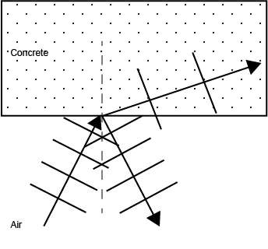

Question 12 (3 marks)

A student is trying to calculate the error in the centripetal force acting on a tennis ball swinging in a horizontal circle around a pole on a string

The data for the calculation is as follows …

Quantity | Amount | Absolute Error | Relative Error
Tennis ball mass | 57.6 g | ± 0.9 g | 1.56 %
Speed of ball | 5.0 m/s | ± 0.05 m/s | 1.00 %
Radius of circle (horizontal) | 1.1 m | ± 0.05 m | 4.55 %

a) Calculate the relative error for each quantity and so complete the data table above.
(1 mark)

b) What is the relative error in the centripetal force? Show working.
(1 mark)
F_{c} = mv²/r

1.56% + 1% + 1% + 4.54%
8.11 %

c) What is the absolute error in the centripetal force? Show working.
(1 mark)

F_{c} = mv²/r
F_{c} = 0.0576 x 5² /1.1
F_{c} = 1.31 N

Error = 1.31 x 8.10 / 100
Error = ±0.106 N

F_{c} = 1.31 N ± 0.106 N
End of Section One
Section Two : Problem-Solving - 50% (75 Marks)

This section has seven (7) questions. You must answer all questions. Write your answers in the space provided.

Spare pages are included at the end of this booklet. They can be used for planning your responses and/or as additional space if required to continue an answer.
Planning: If you use the spare pages for planning, indicate this clearly at the top of the page.
Continuing an answer: If you need to use the space to continue an answer, indicate in the original answer space where the answer is continued, i.e. give the page number. Fill in the number of the question(s) that you are continuing to answer at the top of the page.

Suggested working time for this section is 90 minutes.

Question 13 (11 marks)

A 2.00 L plastic coca cola bottle is partially filled with water and compressed air. When the seal on the bottle is broken the water and air forces its way out of the bottle launching the bottle in to the air. Ignore air resistance in your calculations.

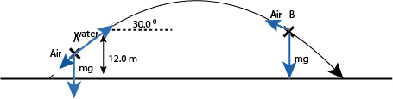

The mass of the bottle changes during the flight as the water blasts out of the bottle. All of the water has left the bottle by the time that the bottle has reached the 12 m high mark.

a) Draw and label the forces acting on the bottle at points A and B on the flight path above.
(2 marks)

b) At the moment that the bottle becomes a projectile it has a height of 12.0 m, a trajectory 30.0 ⁰ above the horizontal and a velocity of 8.50 m/s along its flight path. What is the maximum height above the ground that it will reach?
(3 marks)

Vertical | Horizontal
v² = u² + 2as
0 = 8.5 Sin 30² + 2 x -9.8 x s
0 = 4.25² + 2 x -9.8 x s
-18.0625 = 19.6s
s = 0.9216 m above 12 m mark

s = 12.9216 m above the ground.
s = 12.9 m above the ground.

c) What is the range of the projectile measured from the moment it becomes a projectile?
(3 marks)

Vertical | Horizontal
v² = u² + 2as  v² = 8.5 Sin 30² + 2 x -9.8 x -12  v² = 18.0625 + 235.2  v² = 253.2625  v = -15.914 m/s  v = u + at  -15.914 = 8.50 Sin 30 + (-9.8) t  -15.914 = 4.25 + (-9.8) x t  -20.164 = -9.8 t  t = 2.0576 | u = s/t  8.5 Cos 30 = s / 2.0576  s = 7.36122 x 2.0576  s = 15.146  s = 15.1

d) At what angle does the bottle hit the ground relative to the horizontal?
(3 marks)
v² = 15.914² + 7.3612²
v = 17.5 m/s

Tan θ = 15.914 / 7.36122
θ = 65.1765 degrees

17.5 m/s at 65.1765 degrees below the horizontal.

65.2 degrees below the horizontal.

Question 14 (10 marks)

One of the games played at a Casino is roulette. In this game a large horizontal wheel containing black and red squares is spun anticlockwise. At the same time a small white 3.74 g ball is sent clockwise around an 80 cm diameter small track or groove built into the outside of the wheel. The ball falls in to one of the squares of the wheel when the speed of the ball is too slow to keep the ball on its track. Assume no rolling friction.
Top View

Side View

a) What is the centripetal force on the ball if it competes one revolution of the circle each second?
(3 marks)
v = 2 pi r / t
v = 2 x 3.142 x 0.4 / 1
v = 2.5136 m/s

F = mv²/r
F = 0.00374 x 2.5136² / 0.4
F = 0.0591 N or 5.91 x 10⁻² N

b) Draw the forces acting on the ball as it rolls around the edge.
(3 marks)

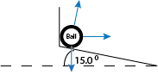

c) As the ball rolls slower all of the centripetal force is provided by the 15.0 ⁰ slope only. At what speed will the ball be travelling in its 80.0 cm diameter circle when this occurs.
(4 marks)

Vertical | Horizontal
-mg + (N Cos 15) = 0  mg = N Cos 15  mg / Cos 15 = N  0.00374 x 9.8 / Cos 15 = N  N = 0.03794 N  Sub to Horizontal | N Sin 15 = mv²/r  0.03794 Sin 15 = 0.00374 x v² / 0.4  v² = 1.05036  v = 1.02 m/s

Question 15 (11 marks)

A binary star system consists of two stars that are orbiting around each other. Each of the two stars orbits around a point called the centre of mass that exists on the line joining the centres of the two stars. The combined mass of the two stars appears to act at the centre of mass (C) generating a centripetal force that acts on each star (m and M) separately. Each star experiences the same centripetal force.

Alpha Beta

Star Name | Distance of star from centre of mass (C) | Period of revolution | Speed of star | Mass of star
Alpha | 7.50 x 10¹⁰ m | 2.13 years  67 217 688 s | 7.01 x 10³ m/s | M
Beta | 3.75 x 10¹¹ m | 2.13 years  67 217 688 s | 3.51 x 10⁴ m/s | m

a) What is the period of revolution of both the stars in seconds?
(1 mark)
T = 2.13 x 365.25 x 24 x 3600
T = 67 217 688 s
T = 6.72 x 10⁷ s
b) What is the speed of revolution of Beta?
(2 marks)

v = 2 pi r / T
v = 2 x 3.142 x 3.75 x 10¹¹ / 67 217 688
v = 35 057.74 m/s
v = 3.51 x 10⁴ m/s

c) What is the centripetal acceleration of Alpha?
(3 marks)

v = 2 pi r / T
v = 2 x 3.142 x 7.5 x 10¹⁰ / 67 217 688
v = 7011.54 m/s
v = 7.0115 x 10³ m/s

a = v² / r
a = (7.0115 x 10³)² / 7.5 x 10¹⁰
a = 6.5549 x 10⁻⁴ m/s/s
a = 6.55 x 10⁻⁴ m/s/s
d) The centripetal force on each of the two stars is the same. Calculate the ratio of the mass of Alpha to the mass of Beta. (Alpha : Beta)
(3 marks)

Method 1 | Method 2
mv² / r = mv²/r  m_{A} v² / r = m_{B} v²/r  m_{A} (7.01 x 10³)² = m_{B} (3.51 x 10⁴)²  7.5 x 10¹⁰ 3.75 x 10¹¹  m_{A} 6.55 x 10⁻⁴ = m_{B} 3.285 x 10⁻³  m_{A} / m_{B} = 3.285 x 10⁻³ / 6.55 x 10⁻⁴  m_{A} / m_{B} = 5 / 1  5 : 1 | mv² / r = mv²/r  m_{A} v² / r = m_{B} v²/r  v = 2 pi r/T  m_{A} 4 pi² r² / T² r = m_{B} 4 pi² r² / T² r  m_{A} r_{A} = m_{B} r_{B}  m_{A} / m_{B} = r_{B} / r_{A}  m_{A} / m_{B} = (3.75 x 10¹¹ / 7.5 x 10¹⁰)  5 : 1

e) If Beta has a mass equal to that of our sun, what is the mass of alpha? If you were unable to find a ratio in part d) use the ratio of 6 : 1 in your answer below.
(2 marks)

m_{A} = 5 x 1.99 x 10³⁰

m_{A} = 9.95 x 10³⁰ kg

By the 6 : 1 ratio

m_{A} = 6 x 1.99 x 10³⁰

m_{A} = 1.19 x 10³¹ kg

Question 16 (10 marks)

A bike rides over a bridge made from a plank (piece of wood) stretched between two triangular boxes. The distance between the two boxes is 3.20 m and the distance between the two wheels is 0.900 m. The combined mass of the bike and rider is 80.0 kg. Assume the rider is on the bike in all questions below. The weight of the bike and rider is 60.0 % on the back wheel and 40.0 % on the front wheel. The plank has a mass of 20.0 kg.

a) Draw and label the forces acting on the plank when the bike (and rider) is in the middle of the plank as shown in the diagram below. Note that the wheels make separate points of contact on the plank.
(3 marks)

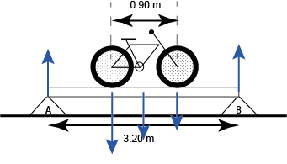

b) Calculate the force on the left and right boxes when the bike is in the middle as shown in the diagram above.
(3 marks)

Take moments about A to find B

Σ M = Σ M

(0.6x80x9.8x1.15) + (1.6x20x9.8) + (0.4x80x9.8x2.05) = 3.2B
(470.4 x 1.15) + (1.6 x 196) + (313.6 x 2.05) = 3.2B
540.96 + 313.6 + 642.88 = 3.2B
1497.44 = 3.2B
B = 467.95
B = 468 N

Σ F = Σ F

A + B = bike + plank
A + 467.95 = (80 x 9.8) + (20 x 9.8)
A + 467.95 = 980
A = 512.05 N
A = 512 N
c) If you could move the bike to any position on the plank to maximise the force on A and still have both wheels in contact with the plank, where would the bike be situated? Draw this on the diagram below.
(1 mark)

Position the bike to the left of the plank with the rear wheel on top of A.

d) Calculate the force on B in the diagram above.
(3 marks)

Take moments about A

Σ M = Σ M

(0.6x80x9.8x0) + (1.6x20x9.8) + (0.4x80x9.8x0.9) = 3.2B
0 + 313.6 + 282.24 = 3.2B
595.84 = 3.2B
B = 186.2 N
B = 186 N

Question 17 (14 marks)

A sailor is calculating the forces acting on the boom of his sailing boat when it is at rest in harbour. The Boom is 1.8 m long and is connected to the top of the Mast by a rope not a sail. The Boom is uniform and has a mass of 30.0 kg.

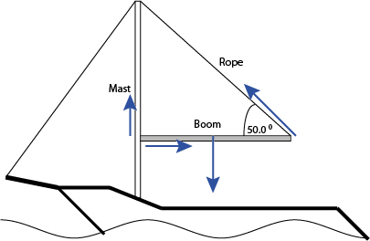

a) Draw all of the forces acting on the boom.
(3 marks)

b) What is the tension in the Rope that joins the end of the Boom to the top of the Mast?
(3 marks)
Take moments about the mast
Σ M = Σ M

(0.9 x 30 x 9.8) = (1.8 x T Cos 40)
264.6 = 1.37888 T
T = 191.89 N
T = 192 N

c) What is the magnitude and direction of the force acting on the Boom at the point of contact between the Boom and the Mast?
(4 marks)

Σ F up = Σ F down

Mast up + 192 Cos 40 = 30 x 9.8
Mast up = 294 – 147.08
Mast up = 147 N

Σ F left = Σ F right

Mast Right = 192 Sin 40
Mast Right = 123.4 N

Add the forces
Resultant² = 147² + 123.4²
Resultant = 191.9 N

Angle
Tan (angle) = 123.4 / 147
Tan (angle) = 40.0 degrees

Resultant = 192 up 40.0⁰ right.

d) A massless pulley is now attached to the Boom 1.50 m from the mast. When the sailor pulls on the Pulley Rope the tension in the Original Rope connecting the mast to the boom increases to 600.0 N. What is the force applied by the sailor to the rope passing through the pulley?
(4 marks)

Σ M = Σ M

(1.8 x 600 Cos 40) = (1.5 x pulley) + (0.9 x 30 x 9.8)
827.32 = (1.5 x P) + (264.6)
827.32 - 264.6 = (1.5 x P)
562.72 = 1.5 P
P = 375.14 N

3 strings = 375.14 N
1 string = 125 N

Question 18 (7 marks)

a) Draw a picture in the box (not a graph) of air which has no sound passing through it.
(1 mark)

The air (dots) is uniformly distributed with no compressions or rarefactions.

b) Draw a picture in the box (not a graph) of air that has a loud sound of frequency 6920 Hz passing through it from left to right. Be sure to show 2 complete wavelengths.
(2 marks)

The air (dots) contains compressions and rarefactions with clearly defined high and low pressure regions.

c) Is this sound in part b) audible to the human ear? Explain with reference to the range of human hearing.
(2 marks)

The human hear can hear from 20 Hz to 20 000 Hz. Consequently the frequency which is in between these extremes can be heard.

d) How would the picture look different if the sound had a higher frequency and smaller amplitude when compared with part b) above?
(2 marks)

Higher frequency (compressions and rarefactions are more closely spaced).

Smaller amplitude (compressions and rarefactions are less distinct).

This page is intentionally blank

Question 19 (12 marks)

A set of slotted masses is hanging from a pulley at the bottom of a piece of string that is run through the pulley as shown.

The student gradually increases the distance between the two retort stands by dragging them away from each other. This alters the angle between the pulley string and the vertical. The student then records the force measured on the spring balance.

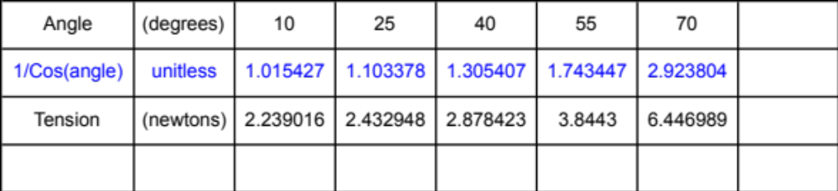

It is thought that the relationship between the angle created in the string and the tension in the string is given by
T = ½ mg / Cos θ

a) What is the independent variable?
(1 mark)
Angle
b) What is the dependent variable?
(1 mark)
Tension
c) Manipulate either the independent or the dependent variable in the data table above in preparation for creating a straight-line graph.
(2 marks)

d) Graph the manipulated data to produce a straight line
(4 marks)
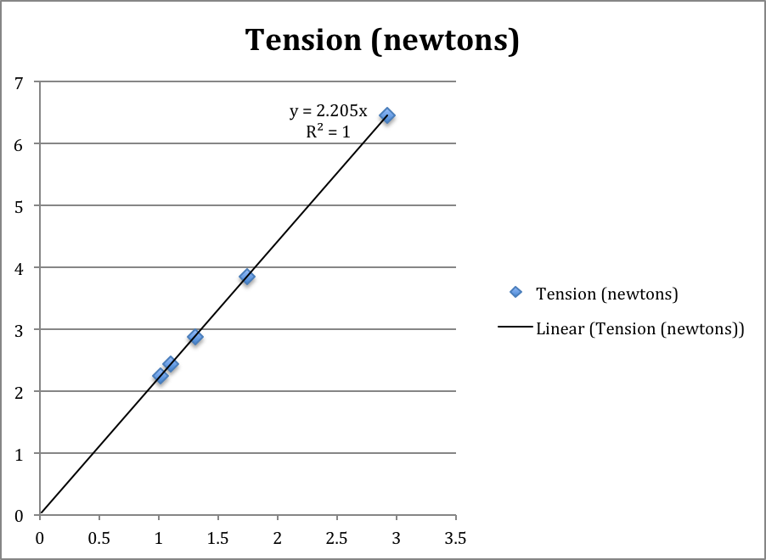

e) Use the graph to calculate the slope of the line
(3 marks)
Slope = rise / run
Slope = 2.205
Slope = 2.20
f) Use the slope of the line to calculate the mass in the equation.
(1 mark)

Slope = ½ mg
2.205 = 0.5 x m x 9.8
2.205 / 4.9 = m
m = 0.450 g

Section Three: Comprehension - 20% (30 Marks)

This section contains two (2) questions. You must answer both questions. Write your answers in the space provided.

Spare pages are included at the end of this booklet. They can be used for planning your responses and/or as additional space if required to continue an answer.
Planning: If you use the spare pages for planning, indicate this clearly at the top of the page.
Continuing an answer: If you need to use the space to continue an answer, indicate in the original answer space where the answer is continued, i.e. give the page number. Fill in the number of the question(s) that you are continuing to answer at the top of the page.

Suggested working time for this section is 36 minutes.

Question 20 (15 marks)

The Physics of Bicycles

What goes in circles but still helps you get to your destination faster… a bicycle!

Figure 1 – A Bicycle with gears

Paragraph 1
Bicycles have been around for hundreds of years and the most successful models have gears. The gears and drive chain on a bike allow the bike to convert between linear-force and rotational-torque and visa versa. This interplay between force and torque allows the bicycle to achieve its purpose as a machine.

Paragraph 2
Firstly we need to discuss cogs. A bike with gears usually has two sets of cogs. One set of cogs is attached to the pedals and cranks. The other set of cogs is attached to the rear wheel. All of the teeth on these cogs are set the same distance apart because the chain links in the chain that mesh with the cogs are all the same size. The chain link size and hence the teeth spacing on a typical bicycle is 9.00 mm. Consequently the circumference of a cog is always a multiple of this 9.00 mm link size.

A diagram of the rear part of a bicycle (relevant parts) is shown below …

Figure 2 – the rear section of a simple bicycle.

Paragraph 3
A flow chart of the force / torque interplay from the pedal to back wheel …

1. Force applied to pedal (weight of person).

2. Force converted to torque by crank.

3. Torque of crank is transferred to the front cog.

4. Torque of front cog is converted to force in chain.

5. Force in chain is passed to the back cog.

6. Force of chain on cog converted to torque.

7. Torque of cog equals the torque given to back wheel.

8. Torque of wheel applies force to the ground.

This is how the force is transferred from the pedals to the ground at right angles.

References

http://en.wikipedia.org/wiki/Bicycle_gearing
Questions.

a) A person is riding a simple bicycle that is using a 40 tooth front cog and a 23 tooth back cog. What is the radius of each of these cogs given that each chain link and hence teeth spacing is 9.00 mm?
(4 marks)

40 tooth | 23 tooth
Circumference = 2 pi r  40 x 0.009 = 2 pi r  0.36 = 2 pi r  r = 0.0573 m | Circumference = 2 pi r  23 x 0.009 = 2 pi r  0.207 = 2 pi r  r = 0.0329 m

b) What is the torque applied to the front cog if the crank is 170 mm long and the complete weight of a 60.0 kg person is applied to the pedal when the crank is at 30.0⁰ to the horizontal?
(3 marks)
M = rF
M = 0.170 Cos 30 x 60.0 x 9.8
M = 86.568
M = 86.6 Nm

c) Calculate the magnitude of the force applied to the chain by the front cog.
(1 mark)
M = rF
86.6 = 0.0572 x F
F = 1513.42 N
F = 1.51 x 10³ N

d) What torque is applied to the back cog by the chain?
(1 mark)
M = rF
M = 0.03294 x 1513.42
M = 49.8522
M = 49.8 Nm

e) What force does the wheel apply to the ground (at a tangent to the wheel) if the wheel has a diameter of 680 mm?
(1 mark)
Radius = 0.680 / 2
Radius = 0.34 m

M = rF
49.9 = 0.34 x F
F = 146.76 N
F = 147 N

f) What is the ratio of the weight force applied to the pedal as compared to the force applied by the wheel to the ground?
(1 mark)

Wt : F
60x9.8 : 147
588 : 147
4 : 1

g) What is the instantaneous acceleration of the bicycle if it has a mass 30.0 kg and the rider has a mass of 60.0 kg?
(2 marks)

F = ma
147 = 90 x a
a = 1.63 m/s/s Forwards

h) Does the bicycle cog system provide the rider with a force advantage or a distance advantage? Explain.
(2 marks)

Distance advantage.

The output force is smaller than the input force.

Or

One turn of the peddles is a smaller circular distance than the distance travelled by the wheels.

Or anything sensible

Question 21 (15 marks)

Good Fenced Make Good Neighbours
(Farm Fencing and Gates)

Note – Diagrams in this article depict wires as a dashed lines and posts as rectangles.
Fences
Paragraph 1
Fencing is an important part of any farm it is often one of the least loved jobs because of the monotony of the repair task and the need to check regularly for damage from animals. If the job can be done correctly when the fence is first installed then money and time can be save in the longer term.

Paragraph 2
Fences are made generally from metal or wooden poles put in the ground vertically with horizontal fencing wire running (nearly without friction) through the fence poles. The horizontal wire is kept tight by attaching it securely to the end poles of the fence line. The wire tension pulls on the end poles only causing them to bend inwards towards the centre of the fence.

Figure 1 - End posts tend to rotate inwards towards the centre of the fence.

Paragraph 3
Many farm fences are 1.4 m high above ground level. The rule used to calculate the depth to which a standard fence post should be buried is “2/3rds of the post length should be above the ground and 1/3rd of the post length should be buried”. This will allow the soil around the post to provide sufficient support to withstand the slight toppling forces of the wires and any bumps from livestock (assuming that the post pivots at ground level). End posts should be buried to the “½ above ½” below rule due to the large forces that the wire places on them. The end posts should also be of a larger diameter.

Paragraph 4
Unfortunately in the longer term the end posts of a fence will rotate inwards. This is because the soil in which the fence post is placed is not totally solid. Soil can instead be thought of as being more like a very thick (viscous) honey. A spoon placed into a cup of honey will stand for a while but will eventually fall over. So it is with the end posts on a fence.

Paragraph 5
To reduce this effect the end post of a fence can be braced (reinforced) either using metal/wooden posts or using fencing wire on the diagonal. Two methods are shown below.

Figure 2a - Post and Wire bracing method. An ordinary post is jammed between the last and second last posts and diagonal wire is applied tightly from the top of the second last post to the bottom of the last.

Figure 2b – Post only bracing method. A diagonal post is applied between the top of the last post and the bottom of the second last post.

Paragraph 6
Fences should not be more than 60 m long if single bracing is to be used and 200 m long if double braced. This is because the changing temperature of the wire as the weather changes will change the amount of force exerted on the end posts, potentially pulling over the end posts.

Gates
Paragraph 7
A fenced field still requires access. This is where gates come into play. Gates are often heavier than the other parts of the fencing system and for this reason gate posts like end posts are thicker and buried deeper (½ above ½ below rule).

Paragraph 8
Gate posts are reinforced differently because the forces of the gate on the post are directed away from the fence rather than towards it.

Figure 3 – Gate post braced with wire.

Questions

a) 3 strands of wire are exerting a force of 890 N each on an end post of a fence. If the post pivots at ground level, what is the torque that the ground must supply to stop the post from falling over?
(3 marks)

M = rF
M = (0.3 x 890) + (0.7 x 890) + (1.1 x 890)
M = 267 + 623 + 979
M = 1869

M = 1.87 x 10³ Nm

b) If a fence post is to stand 1.20 m above the ground, how deeply must that post be buried if it is …

i) an ordinary post?
(1 mark)
0.6 m

ii) an end post?
(1 mark)
1.2 m

c) Why does the tension in the wire vary as the temperature of the wire changes?
(1 mark)
Thermal expansion and contraction. (1 mark)

Extra information for studying students …
When the wire heats up the wire expands and the average distance between the atoms (particles) increases. This reduces the tension in the wire.

d) Will the tension in a strand of wire increase or decrease as the temperature drops?
(1 mark)
Increase Decrease (please circle one only)

e) Label each of the pieces of this braced end post set up as being under a tension force, compression force or bending force.
(4 marks)

 | Tension, Compression or Bending
A | Bending
B | Compression or Bending (if you include its weight)
C | Tension
D | Compression

f) What is the horizontal force provided by the top hinge on this 100 kg uniform gate? The hinges are symmetrically spaced 90 cm apart. The gate is 1.50 m long and 1.20 m high. Assume the bottom hinge supports the full weight of the gate.
(4 marks)
Σ M_{clock} = Σ M_{anti}

(0.75 x 100 x 9.8) = (0.9 x F)
(735) = (0.9 x F)
F = 816.666 N

F = 817 N Towards the post

End of Exam

